Project NAME

<Paragraph describing the project>

Project Owner:  Project Manager: | Executive Sponsors:  Stakeholders:

Timeline:
<Either a graphical or tabular timeline specifying where the project is in relation to expected schedule>

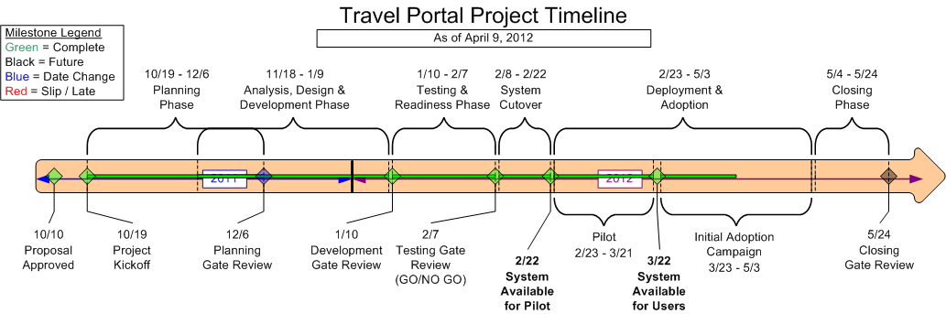
SAMPLE

Progress:
- <things achieved or completed as of the last status update>

Risks / Issues:
- <Potential risks or existing issues which are or could jeopardize the project. Carefully decide what should be reported here.>

Next Steps / Deadlines:
- <Items which will be completed before the next status report>
- <Major upcoming project deadlines>

